Northstar Middle School
PTSA Executive Board Meeting
Tuesday, October 25, 2022
6:30 pm, FAC Classroom

Agenda

- Welcome

- Secretary’s Report
  - Review & Approve September 2022 Meeting Minutes

- Treasurer’s Report
  - Review & Approve Treasurer’s Report
  - Discuss Guthrie budget line update (Cindy)

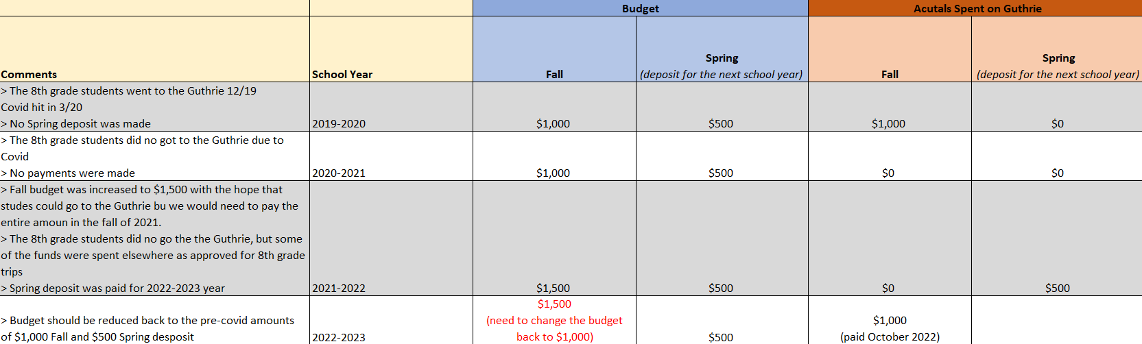

- Principal Comments

- Old Business:
  - Conference Lunch Recap
  - Welcome New FAC Committee Members

- New Business:
  - Upcoming Volunteer Opportunities
  - Membership Update (Nicole)
  - Upcoming Restaurant Fundraisers
    - Upcoming Dates
      - Tuesday, November 1, DQ Pinehurst, 4PM-9PM
      - Tuesday, December 6, DQ Pinehurst, 4PM-9PM
      - Thursday, December 15, Panera, 4PM – 8PM

  - Scrip Program Update
    - Scrip software purchase

- Teacher Comments
  - 6th
  - 7th
  - 8th

- Student Comments

- Family Advisory Committee Meeting Summary (Available in meeting minutes)

- Adjourn

2022-2023 Executive Board and General Meetings. Mark your calendar now!
- Tuesday, August 9 – Executive Board Meeting
- Tuesday, September 13 – General Meeting
- Tuesday, October 25 – Executive Board Meeting
- Tuesday, January 10 – Executive Board Meeting
- Tuesday, February 7 – Executive Board Meeting
- Tuesday, April 4 – General Meeting
- Tuesday, May 9 – General/Executive Board Meeting & End of Year Celebration
All meeting times are at 6:30 p.m.
Executive Board Meetings are held in the staff lounge unless otherwise noted.
General Meetings are held in the Commons.

Your attendance is important! If you are unable to attend, please call or email:
- Cindy Swing (715-461-0836/c_swing@sbcglobal.net)

The mission of the Northstar Middle School PTSA is to be advocates for our children and their safety, to model the core values of the Eau Claire community and schools, and to enhance our children’s education by building partnerships between school, families, students, and community. We do this with the support of our National and State PTA.

