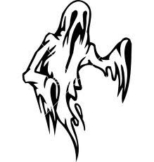
October
Sunday | Monday | Tuesday | Wednesday | Thursday | Friday | Saturday
1 | 2 | 3  - Robins Elementary K-Kids board meeting @ Robins Elementary (3:45-4:45pm) | 4 | 5  -Meeting (7:15am) in the Commons!  - Lakeshore Elementary Conferences @ Lakeshore Elementary (Shifts 4:15-6:15 or 6-8pm) | 6 | 7
8 | 9 | 10  - Robins Elementary K-Kids @ Robins Elementary (3:45-4:45pm) | 11  -Memorial HS Campus Clean Up @ meet in the commons (3:15-4:00) | 12  -Meeting (7:15am) in the Commons! (Membership dues next week!) | 13  No School | 14  -Making Strides Against Breast Cancer Walk @ State Theatre (Multiple Shifts 7am-12noon)
15 | 16 | 17  - Robins Elementary K-Kids @ Robins Elementary (3:45-4:45pm) | 18  - Adopt a Highway with Kiwanis @ EC Memorial; under the eagle (3:15-4:15pm) | 19  -Meeting (7:15am) in the Commons!  (Membership Dues due!!) | 20 | 21
22 | 23 | 24 | 25 | 26  -Meeting (7:15am) in the Commons!  - Meadowview Conferences Babysitting @ Meadowview Elementary School (4-6 or 6-8pm) | 27  No School | 28
29 | 30 | 31  -Trick or Treat for UNICEF | 1 | 2  -Meeting (7:15am) in the Commons! | 3 | 4

