School Newsletter
The Importance of Handwashing
COVID-19 (coronavirus) can be spread through air with breathing, talking, and coughing. It is also spread when that air lands on commonly touched items (such as doorknobs, light switches, electronics) and then people touch their mouth or eyes before washing their hands.

Washing your hands correctly throughout the day will help prevent sickness.
Below are the 5 steps to good handwashing from the CDC:
- Wet your hands with clean water and apply soap
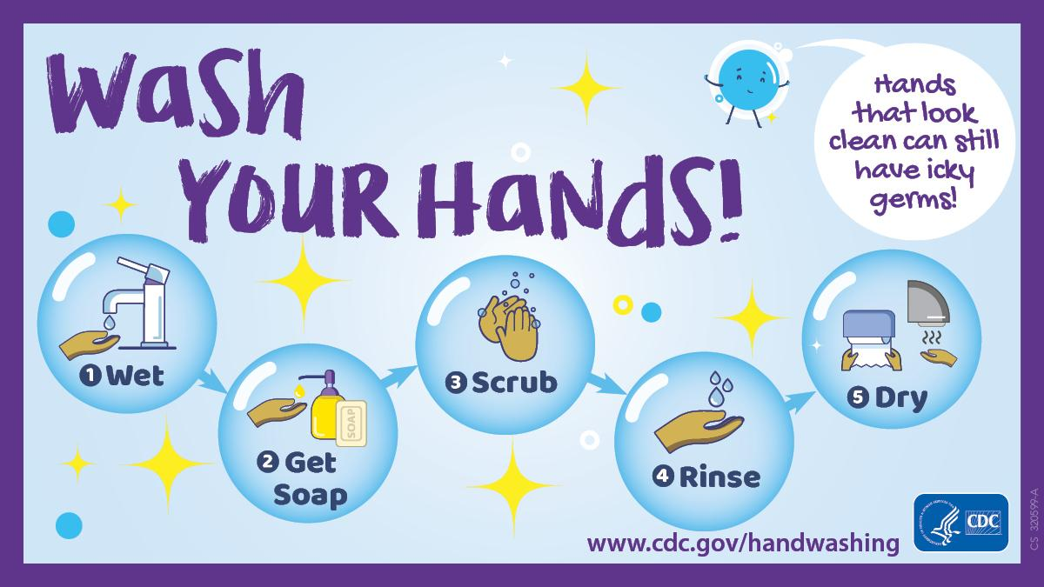
- Get soap. Lather your hands by rubbing them together with the soap. Lather the backs of your hands, between your fingers, and under your nails.
- Scrub your hands for at least 20 seconds. Need a timer? Hum the “Happy Birthday” song from beginning to end twice.
- Rinse your hands well under clean, running water.
- Dry your hands using a clean towel or air dry them
When is it important to wash your hands?
• After going to the bathroom
• Before eating
• After coming home from school
• After blowing your nose, coughing, or sneezing
• After being around someone that is sick

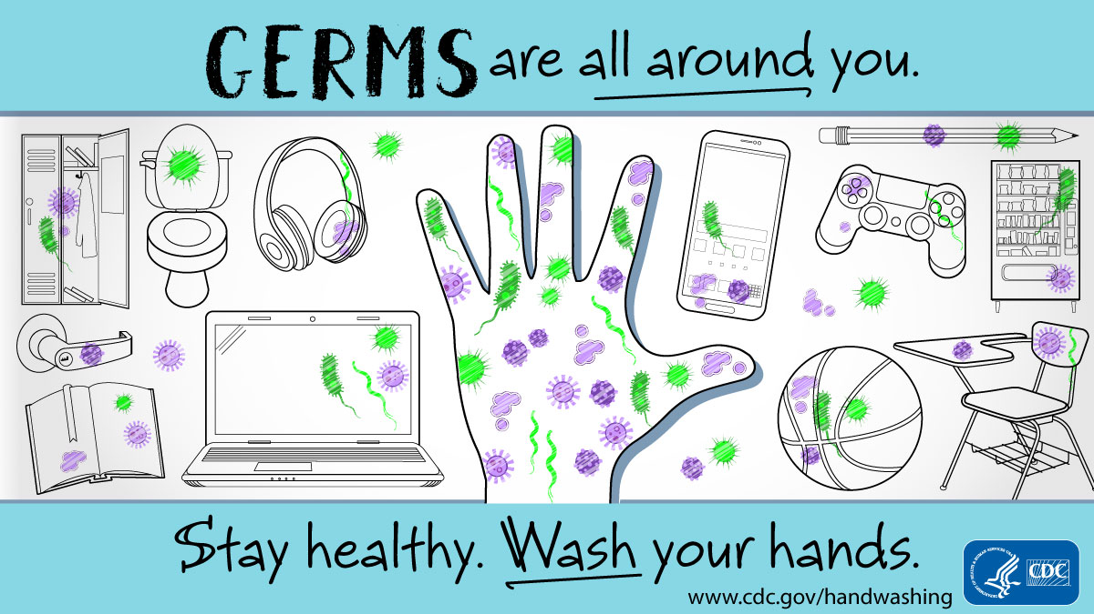

Story: The Wask in a Mask Washes his Hands
It can be hard to know why you need to wash your hands if you can’t see that they’re dirty. Even though you can’t see the germs on your hands, it is important to know that they are still there! In collaboration with the Eau Claire City-County Health Department, UW-Eau Claire nursing students created another story with the character “The Wask in a Mask.” In this story, the Wask shares why everyone needs to wash their hands many times throughout the day!

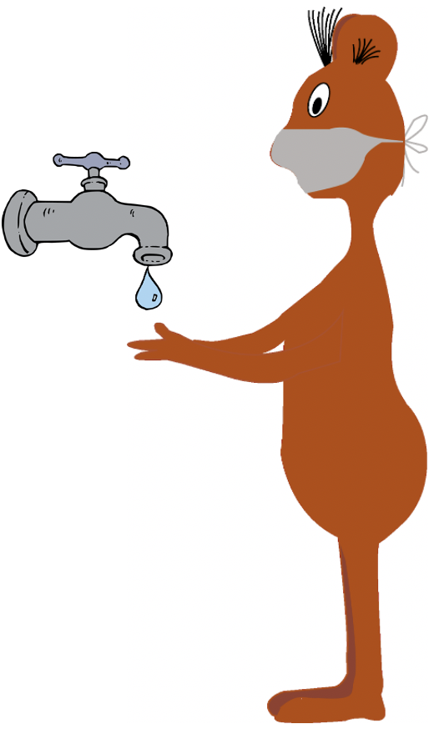
“Wash your hands!” cried the Wask.
It's important to do.
Wash them after going places
and before you touch your faces.
Wash them before eating
and after coughing or sneezing.

“Wash your hands!” cried the Wask.
It’s important to do.
Wash them after going potty
or after touching lots of books.
Wash them any chance you get,
no germ can be overlooked.

“Wash your hands!” cried the Wask.
It's important to do.
Wash them with warm water
and with a little bit of soap.
Wash them with hand sanitizer
after you pet a goat.

“Wash your hands!” cried the Wask.
It's important to do.
Wash them as you count to 20
or sing a song in your head.
Wash them long enough
so the germs don’t spread.

“Wash your hands!” cried the Wask.
It's important to do.
Wash them, wash them.
It's an easy task.
Wash them, wash them
and wear a mask!

After reading the story, here are a few questions that can help you talk about handwashing with your kids:
- Why should you wash your hands for at least 20 seconds?
Answer: Washing your hands for at least 20 seconds helps stop the spread of germs.
- When should you wash your hands?
Answers: You should wash your hands before eating, after you cough or sneeze, and after you pet an animal.
- What are the different ways you can wash your hands?
Answer: You can wash your hands with soap and water or hand sanitizer if your hands don’t look dirty.

