Physical Education Lesson Plan

Grades K-5 Activities - (June 1 – June 5)

Essential Learning Statement: Your Physical Education teacher will provide you a variety of physical activities and games to play either inside or outside of your home, needing minimal equipment or toys to play. These activities will help our bodies to stay healthy, and our minds to stay happy! The goal is to play each suggested activity for 10 minutes per week; however, we recommend children are active and moving for extended times every day. Additional skills and bonus activities will be included each week for children who would like to extend their movement beyond 10 minutes and continue practicing learned skills from this school year.

Always ask an adult’s permission before doing any of these activities. Also, get outside for fresh air and physical activity/movement as often as you can!

___________________________________________________________________________________

Activity: Locomotor Bucket Relay

Skills: Locomotor movements (walk, run, gallop- forward facing, heel toe, jump-2 feet, hop-1 foot, skip- step, hop, slide- sideways, leap- one foot to other foot)

How to play: Provide your child with a cup and two buckets (one smaller, one larger). Place the smaller bucket a short distance from the larger bucket and fill the larger bucket with water. Have your child scoop water from the larger bucket and fill the smaller one. To make the game more challenging, have your child perform the locomotor movements as they move from bucket to bucket.

________________________________________________________________________________________

Activity: Exercise Challenge

Skills: Fitness

How to play: Pick four exercises and repeat each one (5-10 times). Examples of exercise; jumping jacks, sit-ups, push-ups, mountain climbers, burpees, etc.

Bonus Activity: Find something straight and flat that you can walk on like a balance beam. Some examples may include: a line on the floor, a crack on the driveway, a piece of string, space between deck boards, a belt, a slender rope or a line on your floor/carpet. If you can’t find an object, just try
- Walk across the beam normal, one foot then the other
- Walk across the beam sideways leading with your right foot
- Walk across the beam sideways leading with your left foot
- Walk across the beam with a heal toe pattern
- Walk across the beam backwards
- Walk to middle of beam and balance on 1 foot
- Walk to middle of beam, balance on 1 foot like an air plane
- Can you hop across the beam or hop 2 times, then walk across
- Can you leap on the beam, maybe leap across the beam
- Walk to middle of beam, can you lower 1 knee to the beam
- Can you turn around on the beam
- Turn sideways and try to jump on the beam

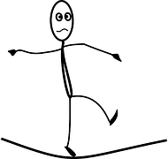
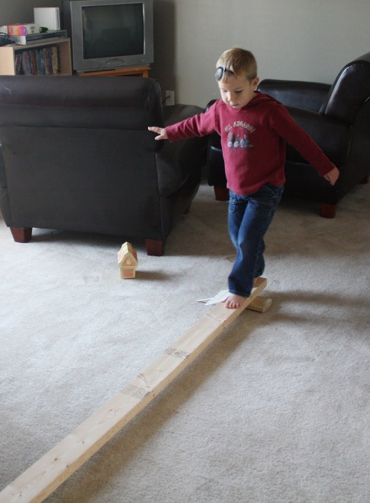
Bonus Activity: can you use these skills or other skill and make a balance beam routine. Try for 3 or more skills in your routine. I would love a video of your balance beam challenge or and email telling me what was easy and what was hard.

