Art for Week of: May 25-29
Choose one (or both!) options below to explore TEXTURE. I would love to see what you create! Feel free to send me a picture by email, cledin@ecasd.us, or through a Microsoft Teams Chat if you have your school iPad at home.
THIS WEEK’S ELEMENT OF ART FOCUS IS TEXTURE
TEXTURE: How objects feel or look like they feel.
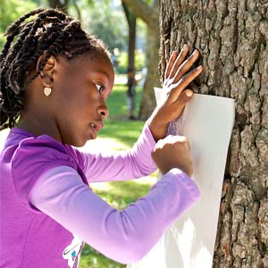
ART CHOICE #1: Nature walk and RUBBINGS
Go outside and FEEL the following items: a rock, sidewalk, leaf, and tree. What words would you use to describe how they feel? Sharp, rough, smooth, soft, hard, bumpy?
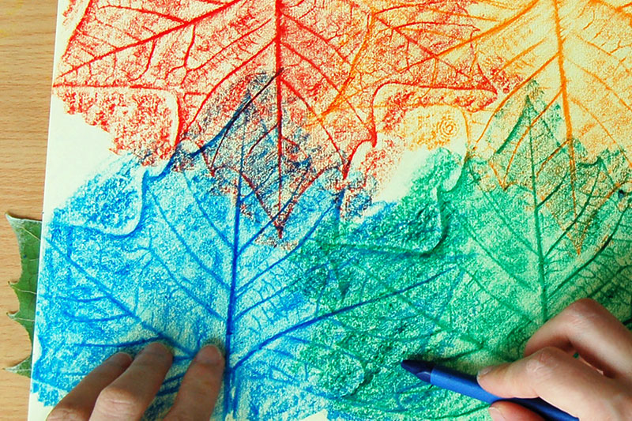
- Place a piece of paper (it can be a recycled envelope or newspaper) on top of a leaf.
- Using the flat side of a crayon, pencil, or marker, rub the tool across the paper where the leaf is hiding underneath. An image of the leaf should appear!
- Try placing your paper against a tree and rub your crayon on the paper.
- Try placing your paper on top of the sidewalk and rub your crayon on the paper.
- Try rubbing your tool across your paper on top of a Lego or spatula from the kitchen!

ART CHOICE #2: Assemblage  Louise Nevelson was a Russian-American artist who created low-relief sculpture like you see in this picture of her. Find out more about Louise Nevelson here.  - Gather items from the recycle bin to put together into an interesting pattern.  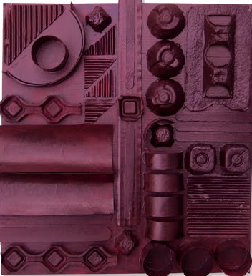  - Looking at the project to the right, can you see the egg cartons, toilet paper tubes, bottle caps, popsicle sticks, and corrugated (wavy) cardboard?  - Tear up or cut up the items you found and place them into an interesting composition. You can place them on the floor or use a background object (like paper or cardboard) to hold the items. TIP: you can use glue or tape to hold the items in place.  - OPTIONAL: This artist painted the finished project to make it the same color. | BONUS RESOURCES  Want to learn more about TEXTURE? Check out these ideas!  Texture Words: Click Here  DIY T-shirt Yarn Video:  https://safeYouTube.net/w/vs4G  Ask a grown up for help with this.  Magazine Texture Collage:  Cut out different textures from old magazines or newspapers and arrange them to create a beautiful image!  