Art Lesson for Week of: April 20-24
Choose one (or both!) options below to explore LINE. I would love to see what you create! Feel free to send me a picture by email, cledin@ecasd.us, or through a Microsoft Teams Chat if you have your school iPad at home.

THIS WEEK’S ELEMENT OF ART IS LINE

LINE: A line is a dot that goes for a walk!

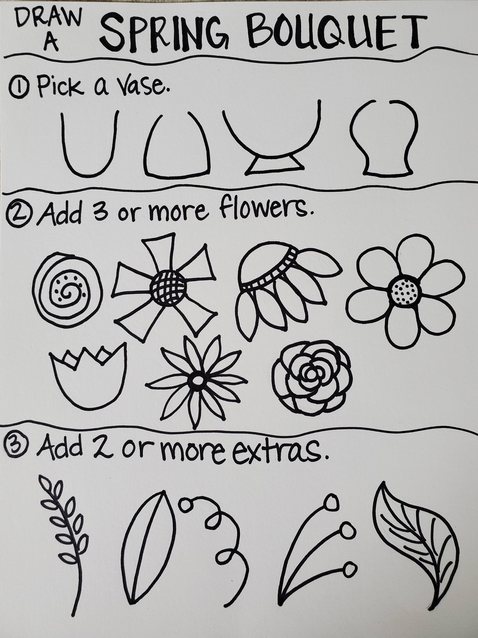
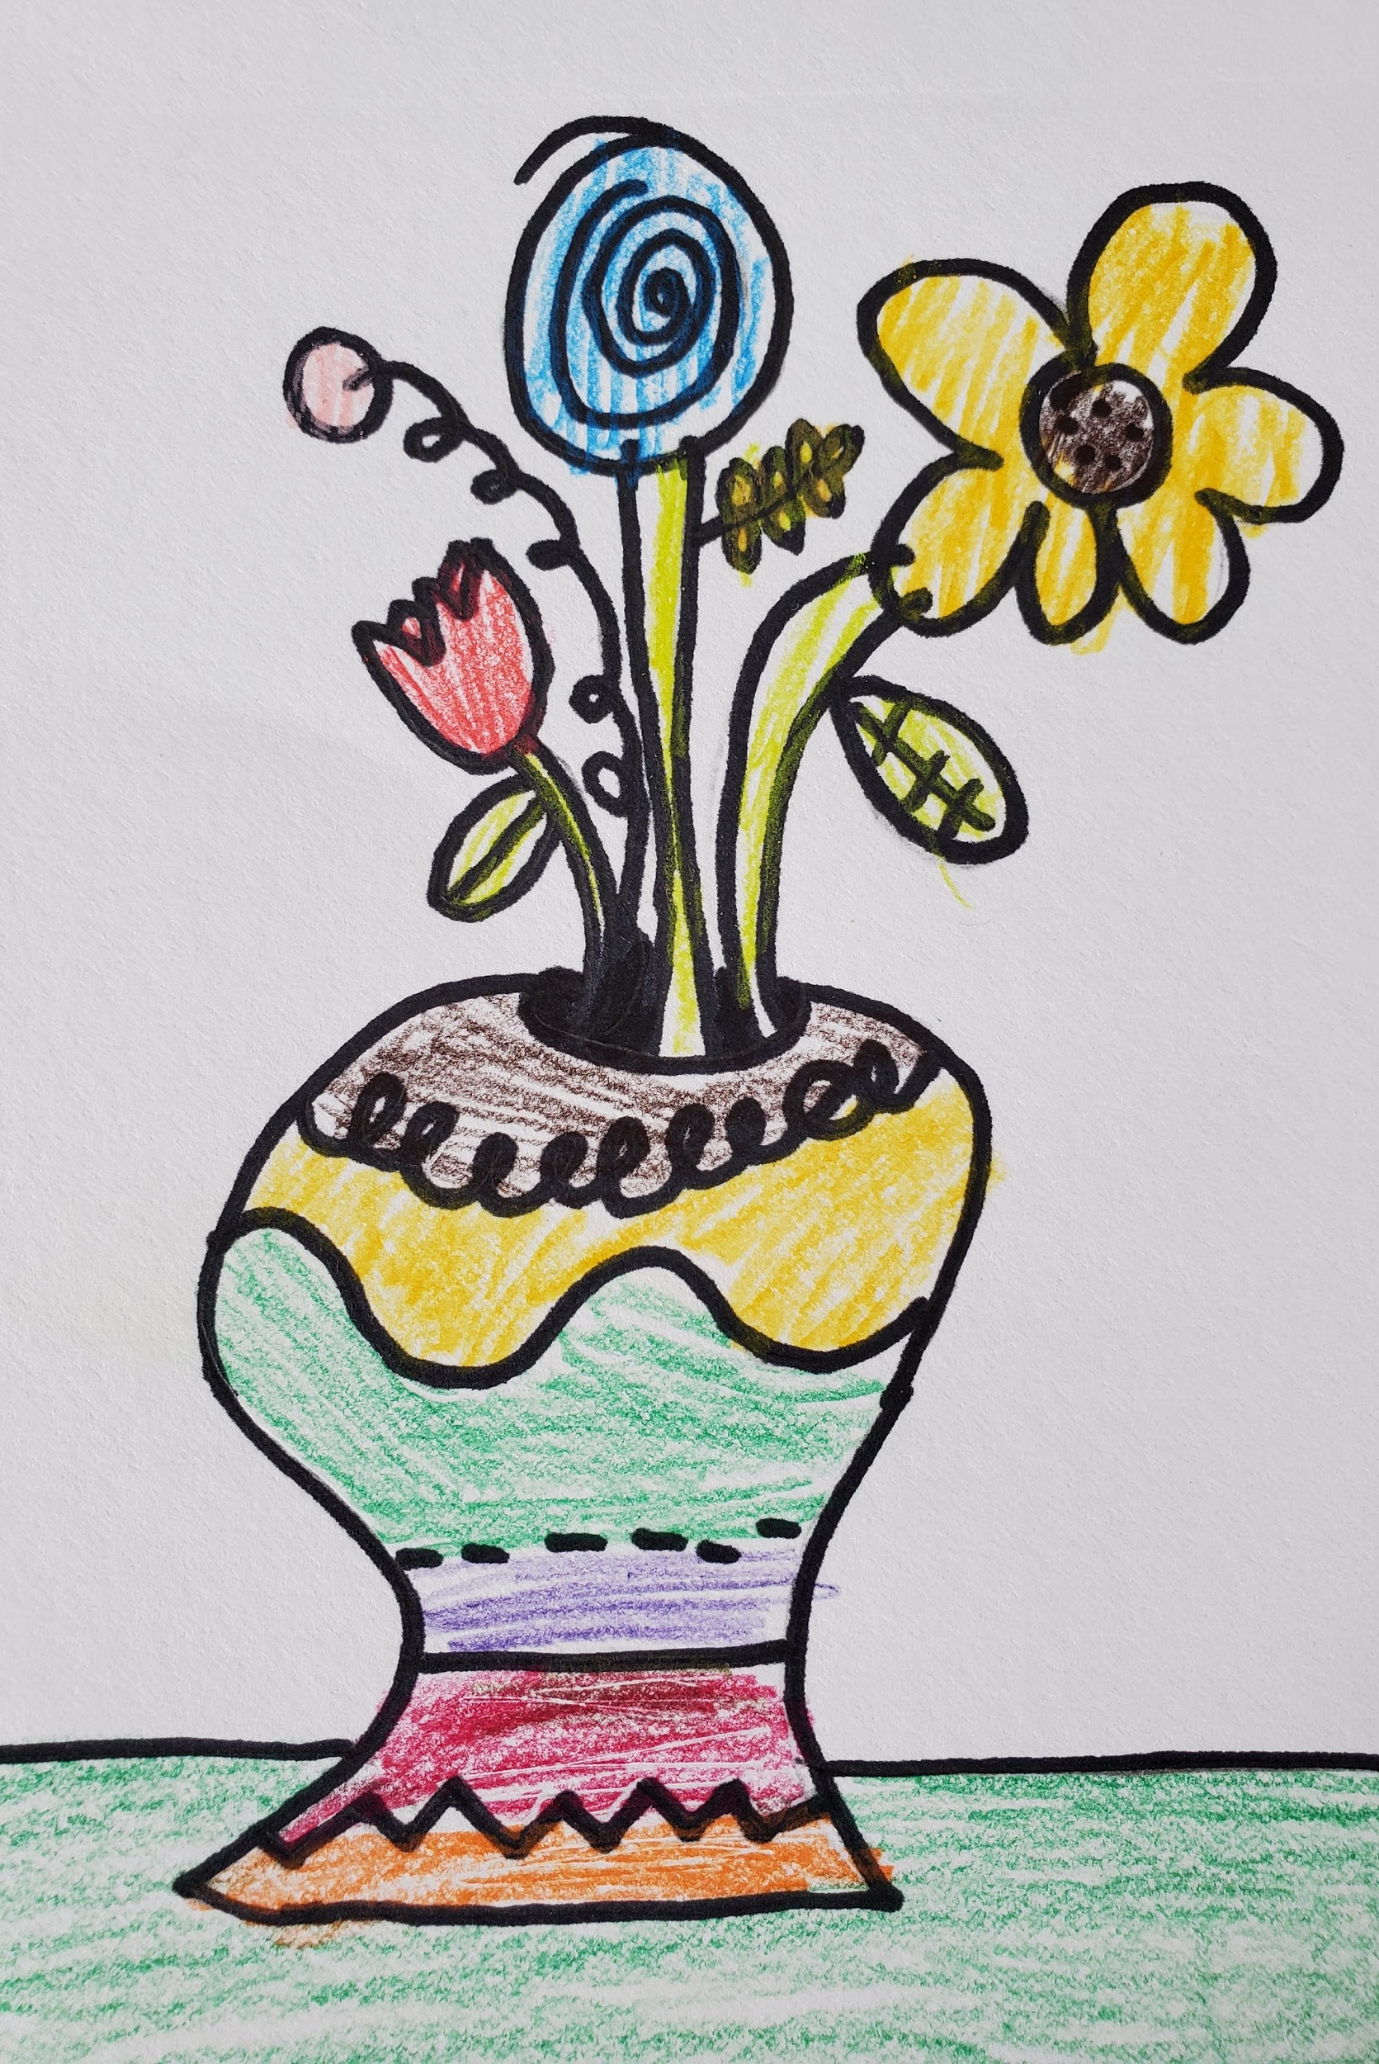
ART CHOICE #1: Spring Bouquet
- Following the steps in the image to the left: draw one vase, 3 or more flowers, and 2 or more extras. All of these are different types of line.
- If you have a marker or pen, you can outline your pencil lines. Notice in the drawing to the right by my son, Greyson, he added lines to his vase!
- Feel free to color your picture using any materials you might have, or leave it black and white.
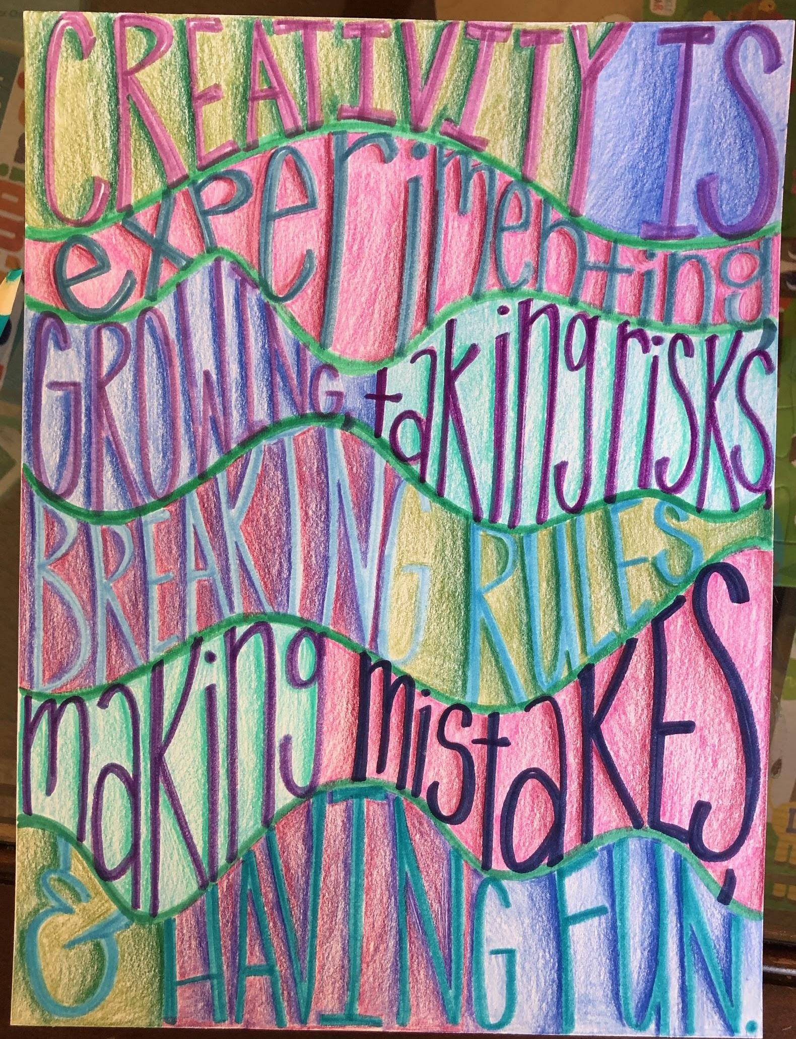  ART CHOICE #2: Inspirational Quote  - Search online, in a book, or around your house for a quote that is meaningful for you.  - On a sheet of paper (can be junk mail or a cereal box!) divide the space up with three to four horizontal wavy lines, depending on the length of your quote.  - Using an erasable tool like a pencil, sketch out the words to your inspirational quote. In the example, we used markers to trace the letters. TIP: Stretch your letters to use the whole space between lines.  - Color the background between the wavy lines with colored pencils. You can also use sharpie for the letters and paint for the background or any combination of tools you have. | BONUS RESOURCES  Want to learn more about LINE? Check out these ideas!  Harold and the Purple Crayon by Crockett Johnson  Visit the Art Institute of Chicago to see how other artists use LINE like Jasper Johns!  BONUS PROJECT IDEA:  Spell out your name instead of a quote like Art Choice #2.

