Art for Week of: May 4-8
Choose one (or both!) options below to explore FORM. I would love to see what you create! Feel free to send me a picture by email, cledin@ecasd.us, or through a Microsoft Teams Chat if you have your school iPad at home.
THIS WEEK’S ELEMENT OF ART FOCUS IS FORM
FORM: A 3 dimensional object.
ART CHOICE #1:  TIN FOIL SCULPTURES  Grab some tinfoil and explore smushing, bending and shaping it into different objects! If you would like to add to your sculpture think about painting it or coloring it with Sharpie markers.  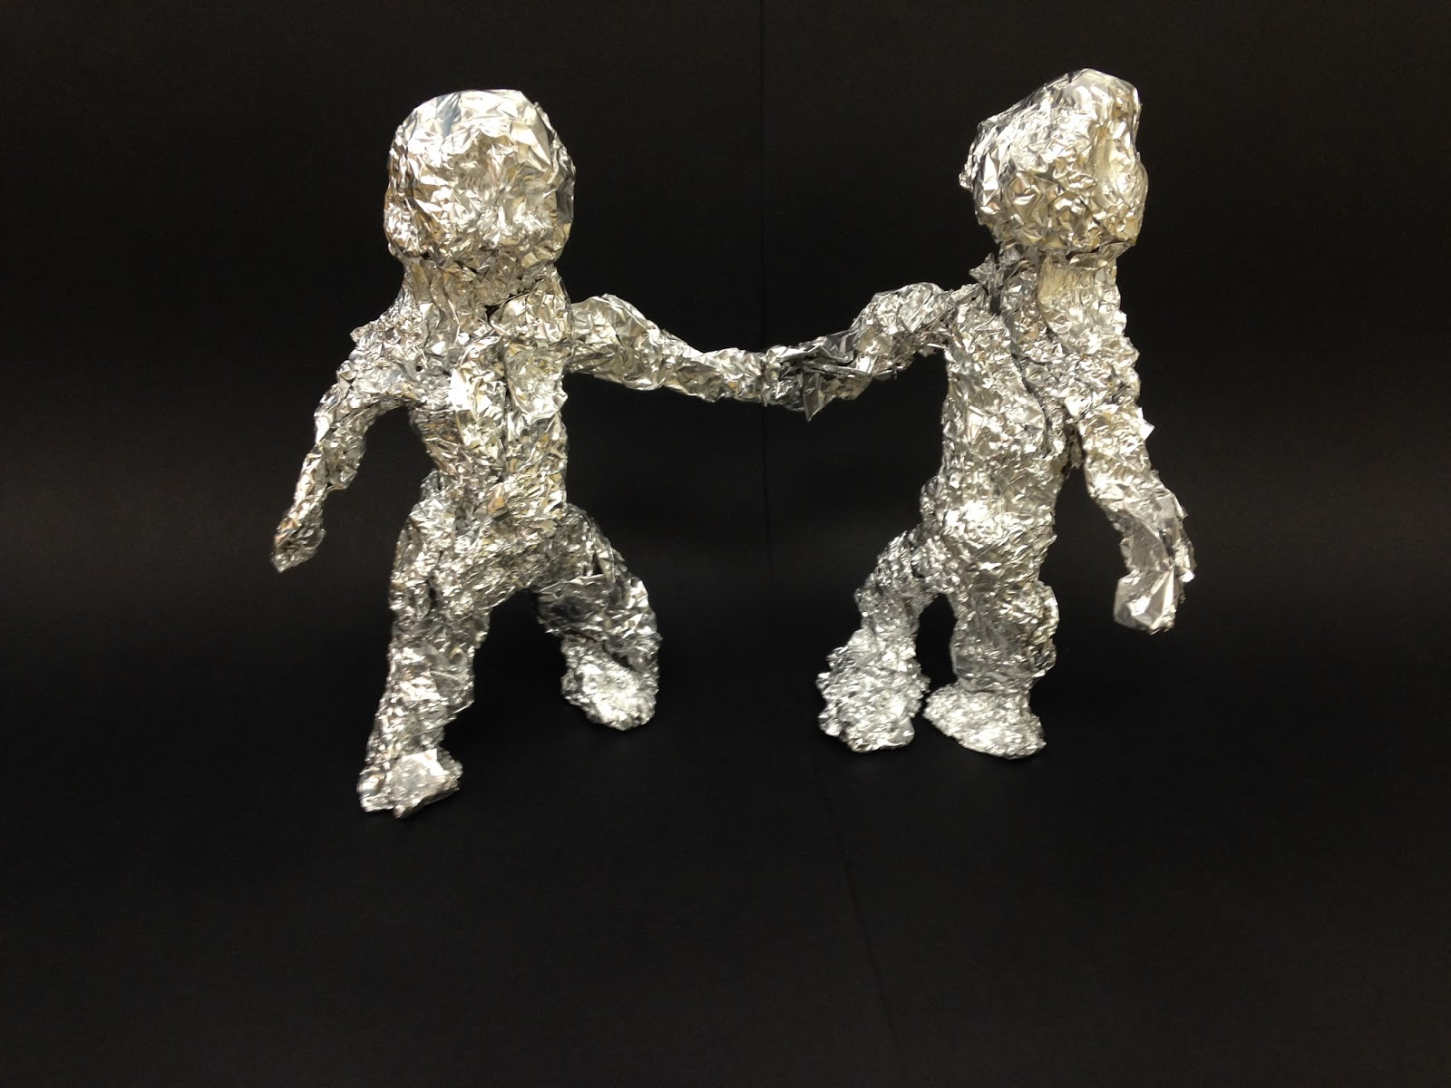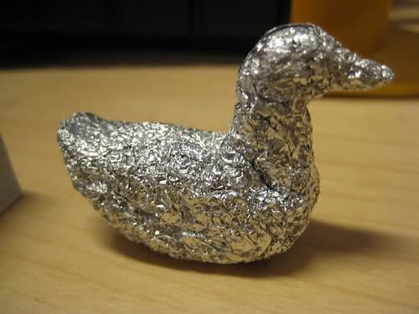  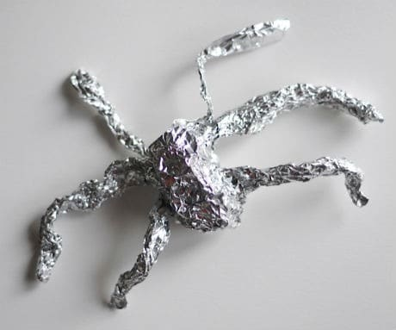 | BONUS RESOURCES  Want to learn more about FORM? Check out these ideas!  Check out Brett Kern making slip cast dinosaures:  https://safeYouTube.net/w/oo1A  Air Dry Clay Recipe:  ¼ cup salt  ¼ cup water  ½ cup flour  Mix all ingredients together in a bowl. Place an old box or newspaper on your table to play with the clay. Smush the clay between your hands. If the clay is too sticky, add a little more flour. Have fun creating different shapes and sculptures. Put it in a plastic bag in the fridge to reuse or leave it out overnight to dry and then you could add color with paint or markers.  ArtHub for Kids: How to Draw a Rubik’s Cube:  https://safeYouTube.net/w/rn1A
ART CHOICE #2:
CARDBOARD TUBE SCULPTURES
Save up empty toilet paper and paper towel rolls and see what you can create with them. Try drawing on them, bending, cutting and gluing things to them. Could you build a city or make a family of animals? What other ideas do you have?
