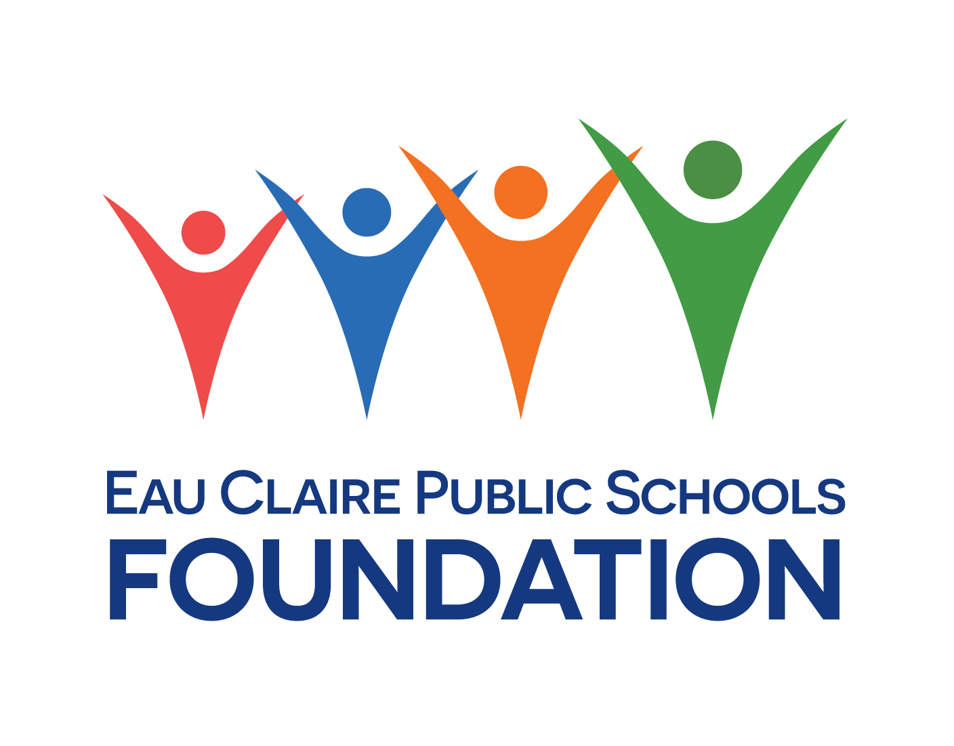
Amy Zais Memorial Scholarship
The Amy Zais Memorial Scholarship for future teachers is dedicated to honoring the legacy of Amy Zais, a passionate educator and North High School Assistant Principal who devoted her life to inspiring and empowering students to reach their full potential. Amy believed every child deserved a quality education and that teachers were critical in creating a positive and supportive learning environment. This scholarship is open to students pursuing a teaching degree in special education or a teaching degree in general education.

Criteria
To be eligible for the Amy Zais Memorial Scholarship, applicants must:
- Be enrolled in an accredited college or university program leading to a degree in education
- Demonstrate a passion for teaching and a commitment to excellence in education
- Have a minimum cumulative GPA of 2.8 on a 4.0 scale
Application
To apply, interested students must submit 5 copies of each of the following:
- A cover page with your name, address, telephone number, e-mail address as well as the title of this scholarship
- A completed application form
- A personal statement of no more than 500 words describing your passion for teaching and your future career goals
- An official transcript of your academic record
Please submit 5 paper copies of your full application (complete with all appropriate documents) to North High School Student Services. Applications must be submitted by April 16, 2024 by 3:30 PM to Ms. Anderson in Student Services. Late applications will not be accepted.

The scholarship committee will review all applications and select the most qualified candidates based on academic achievement, leadership potential, and commitment to excellence in education. Applicants who demonstrate an interest in special education will be given priority. Recipients of the scholarship will be notified at the PRIDE Awards Ceremony and will be awarded a financial award to be used towards educational expenses.
The Amy Zais Memorial Scholarship for future teachers is a fitting tribute to a remarkable educator who inspired countless students to pursue their dreams and make a difference in the world. We hope that this scholarship will help to continue Amy's legacy by supporting the next generation of teachers who share her passion for education and dedication to student success.

