Shepherd’s Closet

Free clothing for children & youth

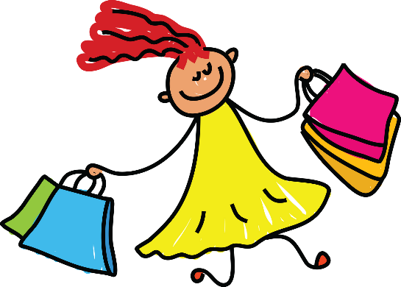

Contact Lutheran Church of the Good Shepherd Secretary @ (715) 834-2959 for information on how to request clothing.

Sizes: Infant through Adult

*Each month every child is allowed 12 clothing items, 3 pairs of underwear & socks, and 1 pair of shoes.*