About Dell Laptop Updates
To ensure that our Dell Laptops are working correctly and efficiently with our District software, they must be maintained by the user. It is recommended that the user frequently check both Microsoft Windows and Dell Command for updates to their systems. We also recommend that you consider completing these processes at the beginning of your week as you may not have work with progress open that could potentially be lost during a restart. In any case, please make sure all work is saved and closed beforehand. For more support, watch this video! 🎥
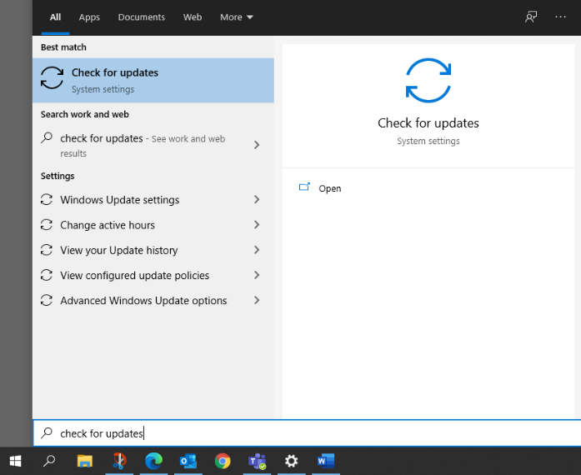
Windows Updates
- Plug in your power/charger cord.
- From the taskbar, select Windows icon or place your curser in the Search Bar.
- Begin typing “Check for Updates”.
- Select Check for Updates when it populates
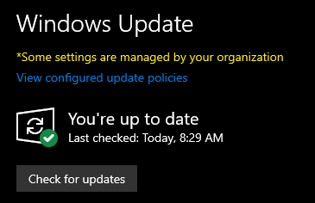
- Select the Check for Updates button.
  - Updates may download and install.
  - If prompted, complete a Windows Restart.
  - Depending on how many updates are available, the restart may take anywhere from 2 to 20 minutes to complete the install of some updates.
  - After restart, we recommend that you repeat this process until you see the message “You’re up to date.”

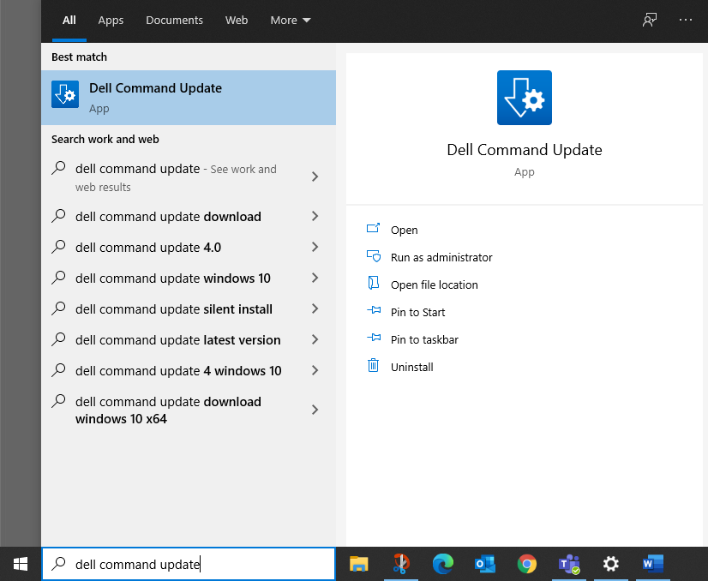
Dell Command Updates
- Plug in your power/charger cord.
- From the taskbar, select Windows icon or place your curser in the Search Bar.
- Begin typing “Dell Command Update”.
- Select and open Dell Command Update when it populates.
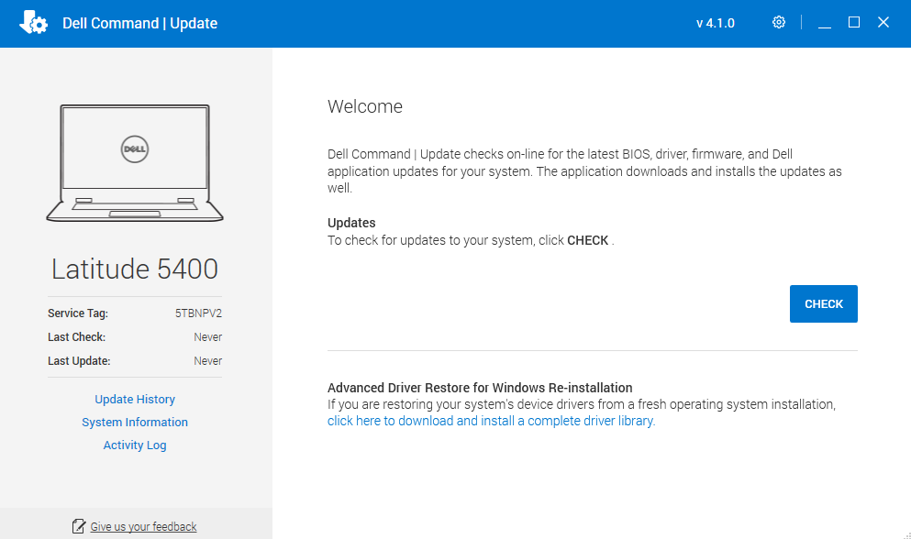
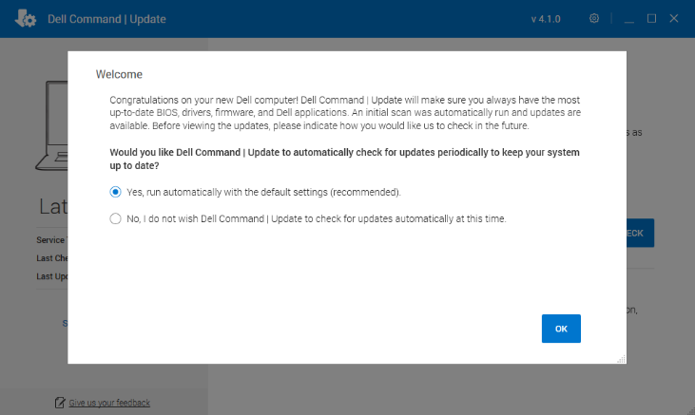
  - Upon first-time use, select Yes, run automatically with the default settings and then select Next
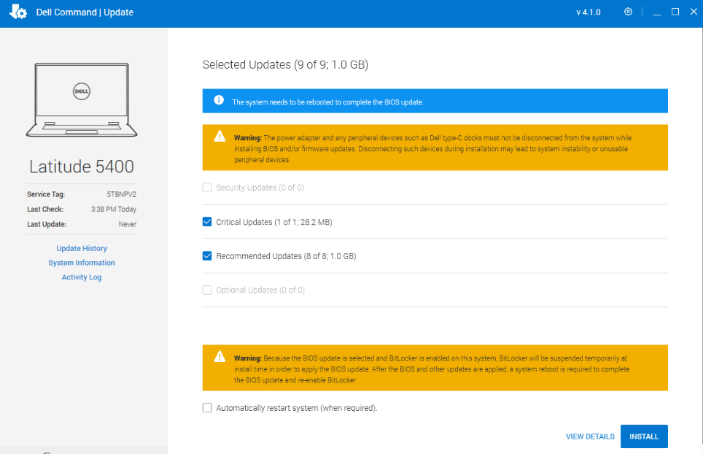
- Select CHECK to begin checking for updates.
- Select Install
  - The update process may take anywere from 5 to 20 minutes and may require a Windows restart. Make sure any progress is saved and apps are closed.
  - You may optionally want to select Automatically restart system (when required) so you don’t have to manually do so.

