Name: ___________________
Calculating Your Work & Power
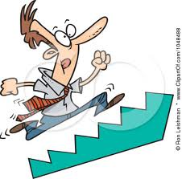
Procedure:
- Find a set of stairs.
- Measure the height of one stair and record.
- Count the total number of stairs and record.
- Time yourself walking up the stairs and record.
- Time yourself running up the stairs and record.
Data
Stair Height, h (m) | Number of Stairs, # | Walk time, t_{w} (s) | Run time, t_{r} (s)

Analysis
- Calculate the height of the stair case.

- Calculate your weight in Newtons. (1kg = 2.2lbs)

- Calculate your Work in climbing the stairs.
  - Walking

  - Running

- Calculate your Power in Watts climbing the stairs.
  - Walking

  - Running

- Calculate your Power in Horsepower climbing the stairs.
  - Walking

  - Running

- Compare the amount of work you did walking and running up the stairs. Explain your answer.

- Which required more power, walking or running up the stairs? Why?

- Compare and contrast power and strength? Give an example of an activity when each one would be beneficial.

