A rabbit starting from rest accelerates to 15 m/s in 5 sec.
- Draw a qualitative motion map.

- Sketch a qualitative x vs. t, v vs. t, and a vs t graph.
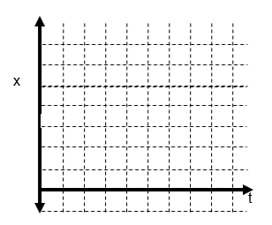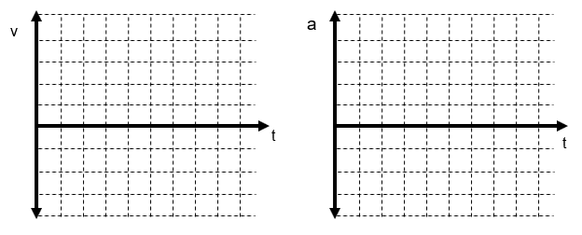

- What is the average acceleration of the rabbit?

- Create a quantitative graph of v vs. t and a vs. t.
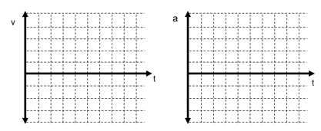
- Show on the v vs. t graph how you would determine the displacement of the rabbit?
- Solve for the displacement using the graph.

- Calculate the displacement using the correct general equation.

