Measurement Activity
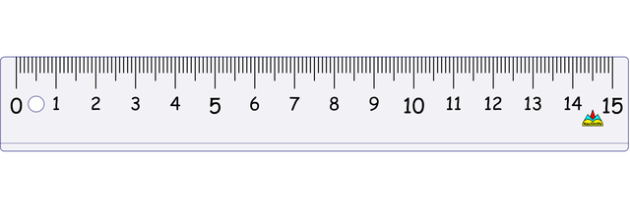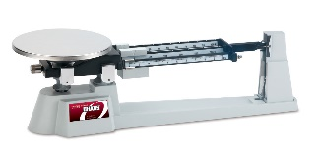
This Photo by Unknown Author is licensed under CC BY-SA
Objective: To practice using a measurement device, to convert to MKS units, and to write numbers using scientific notation on a classroom or backpack object.
- Measure and record the length of the object. ________________

- Change this to MKS units.

- Write the answer from a in scientific notation.

- Measure and record the width of the object. ________________

- Change this to MKS units.

- Write the answer from a in scientific notation.

- Measure and record the mass of the object. ________________

- Change this to MKS units.

- Write the answer from a in scientific notation.

