Power Tower
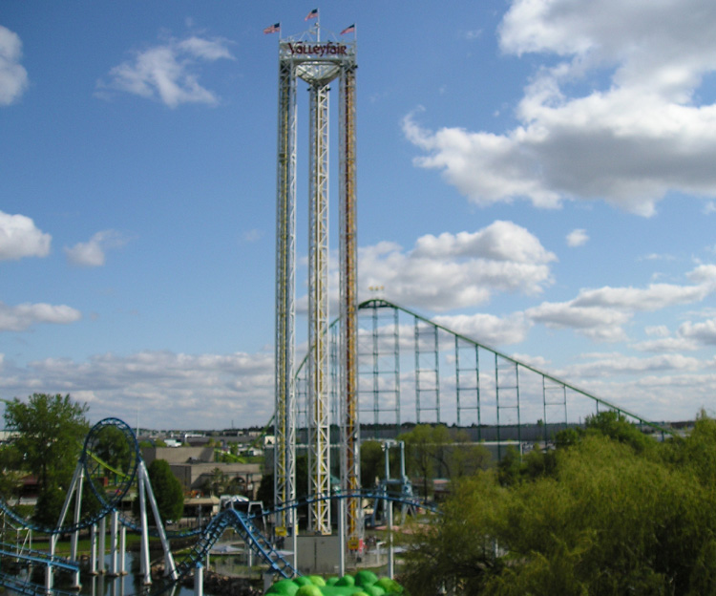
D
C The end of the white hydraulic tube.
B The top of the white hydraulic tube.
A Maximum Height of Riders
What to do at the park?
- Find the maximum height of the car (Point A).
- Find the height of the car when braking begins (Point B) [HINT: Look for the top of the white hydraulic tube.].
- Find the height of the car when the car stops at the bottom (Point D).
- Collect acceleration data using a Vernier accelerometer (throughout the ride).

Measurements and Observations:
Point A = height by triangulation
Height
Angle 1 = ____________ Angle 2 = ___________ Distance B = ____________

Point B = height by triangulation
Height
Angle 1 = ____________ Angle 2 = ___________ Distance B = ____________

Point D = height by triangulation
Height
Angle 1 = ____________ Angle 2 = ___________ Distance B = ____________

Carefully observe:
- Describe the motion of the car on the way up and down. Does the acceleration change when the car passes the hydraulic tube, and if so, by how much? (Look at your data.) What would account for this change?
- Observe the amount of force you feel from the seat pushing you up and the bar pushing you down throughout the ride. (See Analysis Question#7)

What to analyze at home?
1. Draw a quantitative energy bar graph for points A, B, & D. The system is YOU and EARTH – that’s it (you need to use a mass of 65 kg per passenger to do this)!
2. Find the average acceleration of the car when initially falling from points A to B, assuming free fall for this region.
3. Find the acceleration of the car from points B to C (when breaking).
4. Draw qualitative position – time, velocity – time, and acceleration – time graphs for one complete cycle for points A to C.
5. Using accelerometer data, draw quantitative force diagrams for you at each of the points indicated in the diagram. You will need to use the average mass of a rider (65 kg) to correctly draw these diagrams.
6. This is one of the few rides in amusement parks in which the average stopping force on the riders can be found by using the Impulse – Change in Momentum relationship. Calculate the change in momentum for an average rider (65 kg) during braking. What is the average braking force?

7. Concentrate only on how forceful you are “pushed” down in the seat, or “lifted against the retaining bar while you are the ride. If you can, try this with your eyes closed for the entire ride!
L = LARGE M = MEDIUM S = SMALL N = NEUTRAL

Where are you pushed? | Into your seat |  |  | or | Into the Bar
At the top | L | M | S | N | L | M | S
Half way | L | M | S | N | L | M | S
At the bottom | L | M | S | N | L | M | S

