Simulation: Gas Laws
For the Teacher

Summary
In this simulation, students will investigate three of the fundamental gas laws, including Boyle’s Law, Charles’ Law and Gay-Lussac’s Law. Students will have the opportunity to visually examine the effect of changing the associated variables of pressure, volume, or temperature in each situation. Also, students will analyze the gas samples at the particle level as well as manipulate quantitative data in each scenario. Finally students will interpret trends in the data by examining the graph associated with each of the gas laws. This lesson accompanies the simulation from the November 2015 issue of Chemistry Solutions.

Grade Level
High or middle school

Objectives
By the end of this lesson, students should be able to
- Understand that pressure and volume have an indirect relationship, when temperature is held constant, as shown with Boyle’s Law.
- Understand that temperature and volume have a direct relationship, when pressure is held constant, as shown with Charles’ Law.
- Understand that pressure and temperature have a direct relationship, when volume is held constant, as shown with Gay-Lussac’s Law.
- Accurately calculate the final values for volume, pressure or temperature of a gas sample based on a set of given conditions.
- Predict the spatial distribution of particles in the gas sample as variables are changed.
- Describe the interaction and motion of particles in the gas sample as variables are changed.
- Interpret trends in the data by examining the graph associated with each of the gas laws.

Chemistry Topics
This lesson supports students’ understanding of
- Gas Laws
- Volume
- Temperature
- Pressure

Time
Teacher Preparation: 10 minutes
Lesson: 45-60 minutes

Materials
- Computer with internet access
- Calculator
- https://www.teachchemistry.org/ gaslaws

Safety
- No specific safety considerations are needed for this investigation.

Teacher Notes
- This simulation is designed so that students can interact with Boyle’s Law, Charles’ Law and Gay-Lussac’s Law separately. Tabs on the top on the screen will allow for selection of the particular law to investigate.
- This simulation is intended for students to practice completing the gas law calculations, as well as to connect specific particle behavior with the associated variable of volume, temperature or pressure.
- In addition, by clicking on the “Add Data” button, students can collect data to create a graph for each of the gas laws.
- Depending on the gas law chosen, the variable that is held constant will not be available to manipulate at any point on that particular screen.
- The arrows that appear near each variable should be clicked on to either increase or decrease the particular variable. The exact values will be displayed at the bottom of the screen in the variable list.
- Note that the Celsius temperature value can be shown on the thermometer, but the kelvin value is used for the calculations. When the Kelvin temperature exceeds 423K, the Celsius thermometer will appear to break, as it exceeds its capacity.

- Answers to the student activity:
- Pre-lab Questions:
  - 1. a. = 4.16
1. b. = 3.52
1. c. = 636

2. a. Volume- References the amount of 3-dimensional space that is occupied by the gas particles. Common units include L, mL, cm³.

2. b. Pressure- Commonly described as force per area. Although it is often difficult for students to explain, gas particles exert a force on any surface, so in turn this is known as pressure. Gas particles exert force during a collision with other particles, as well as with the surface of a container. The more often the particles of a gas collide (with one another or with a surface), the higher the gas pressure will be. Common units include: atm, kPa, mmHg, psi.

2. c. Temperature – this is a measurement of the kinetic energy (motion, speed) of the gas particles. The faster the particles are moving, the higher the temperature will be. Common units include: K, ⁰C, ⁰F (in order to solve a gas law equation the Kelvin temperature value must be used).

- Answers to the student activity:
  - Boyle’s Law Activity Questions:
  - 1. Temperature
2. a) Space between particles decreases; the number of collisions between particles increases as well as the number of collisions with the surface of the container.
2. b) P₂ = 1.76atm
2. c) n/a
3. a) Space between particles increases; the number of collisions between particles decreases as well as the number of collisions with the surface of the container.
3. b) V₂ = 4.29L
3. c) n/a
4. a) b) c) Answers shown in completed data table below:
P₁ = 1.00atm | P₂ = 1.50atm | P₃ = 2.00atm | P₄ = 2.50atm | P₅ = 2.90atm
V₁ = 3.00L | V₂ = 2.00L | V₃ = 1.50L | V₄ = 1.20L | V₅ = 1.03L

4. d) Volume will decrease.
4. e) Indirect relationship (student justification will vary)
4. f) The gas pressure inside the bottle will double. Since the variables in Boyle’s law are indirectly related, they will have opposite outcomes.
  - Charles’ Law Activity Questions:
1. Pressure
2. a) The particles should begin to move faster as the temperature increases, and the space between the particles should increase.
2. b) 4.46L
2. c) Direct relationship, as temperature was increased, the volume of the gas also increased.
3. a) As the volume is decreased the space between the particles decreases, and the speed of the particles decrease (because temperature is also decreasing). Since pressure remains constant the number of collisions between particles should not change.
3. b) T2=185K
3. c) n/a
3. d) -88⁰C
4. a) The graph should have a positive slope.
4. b) When the temperature of a gas increases, the volume will also increase, and vise-versa. When the temperature of a gas decreases, the volume will also decrease, and vise-versa.
5. The gas would need to expand its volume to twice its original amount, this may cause the sealed container to explode!
  - Gay-Lussac’s Law Activity Questions:
1. a) Charles’ Law.
1. b) Volume.
1. c) This means that Gay-Lussac’s law will also have a direct relationship between its variables.
2. a) b) c) Answers shown in completed data table below:
P₁ = 1.00atm | P₂ = 1.50atm | P₃ = 2.00atm | P₄ = 2.50atm | P₅ = 2.90atm
T₁ = 298K | T₂ = 447K | T₃ = 596K | T₄ = 745K | T₅ = 864K

2. d) As the pressure of the gas is increased, the temperature of the gas also increases. This is a direct relationship between the variables.
3. a) The speed of the particles will decrease, and the number of collisions between the particles, as well as the number of collisions with the surface of the container will also decrease.
3. b) 0.530atm
3. c) n/a
4. The pressure would also decrease by half of its original value, as long as the volume remains constant.
  - Checking Comprehension Questions:
1. T₂ = 429K
2. P₂ = 1.39atm (make sure to remind students to convert the temperature values to Kelvin before solving the problem).
3. V₂ = 2.70L

For the Student
Gas Laws
Background
In this investigation you will examine three gas laws including Boyle’s Law, Charles’ Law and Gay-Lussac’s Law. You will explore how manipulating the variables of volume (L), pressure (atm) and temperature (K) can affect a sample of gas. The formula for each of the gas laws are:
Boyle’s Law:
P₁V₁ = P₂V₂
Gay-Lussac’s Law:
P₁ = P₂
T₁ T₂
Charles’ Law:
V₁ = V₂
T₁ T₂

Prelab Questions
- Solve for “x” in the following algebraic equations and report your final answer with the correct number of significant digits:

  - (1.34)(5.46) = (1.76)(x)

  - 4.38 = x_
332 267

  - 2.25 = 4.85_
295 x

- Briefly describe, in your own words the meaning of each of the following variables, and common units of measurement associated with each:

  - Volume
  - Pressure
  - Temperature

Procedure
Visit http://www.teachchemistry.org/gaslaws. Make sure that you select the “Boyle’s Law” tab to begin; it will be shown in white. You should see the picture below on your screen.
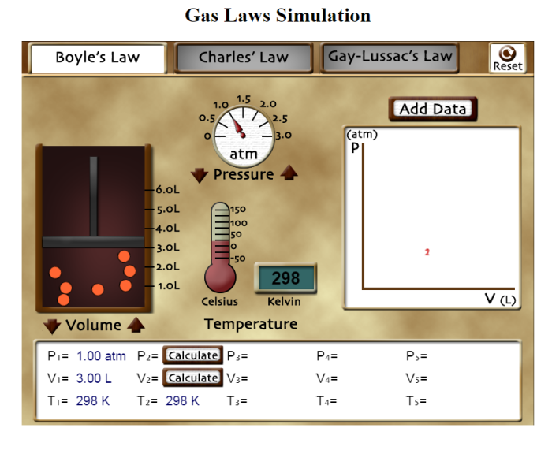
Boyle’s Law
- Which one of the three variables: Pressure, Volume or Temperature cannot be changed in Boyle’s Law? This variable is considered a constant.

- Using the volume control arrows, reduce the volume of the gas to 1.70L.
  - In the space below record your observations regarding the behavior of the particles in the gas sample as the volume is reduced. Make certain to discuss collisions in your comments.
- Calculate the new pressure value for the gas, showing all of your work.
- Check your final answer for part b by clicking the calculate button next to P₂.

a. Observations when Volume is reduced: | b. Calculation
 | P₁V₁ = P₂V₂

- Press the reset button at the top right of the screen.
Using the pressure control arrows, reduce the pressure of the gas to 0.700atm.
  - In the space below record your observations regarding the behavior of the particles in the gas sample as the pressure is reduced.
  - In the space below calculate the new volume value for the gas.
  - Check your final answer for part b by clicking the calculate button next to V₂.

a. Observations when Pressure is reduced: | b. Calculation
 | P₁V₁ = P₂V₂
- Press the reset button at the top right of the screen.
  - Using the pressure control arrows, increase the pressure value to 1.50atm, and fill in the corresponding V₂ value in the data table below.
  - Press the Add Data button. Using the pressure control arrows, increase the pressure to 2.00atm and fill in the corresponding V₃ value in the data table below.
  - Repeat step b for pressure values of 2.50atm and 2.90atm.

P₁ = 1.00atm | P₂ = 1.50atm | P₃ = 2.00atm | P₄ = 2.50atm | P₅ = 2.90atm
V₁ = | V₂ = | V₃ = | V₄ = | V₅ =

  - Based on the data collected in the table above, what trend can be observed for volume of a gas when the pressure of the gas is increased?
Important Terms
Direct relationship: A relationship between two variables, where a change in one variable results in the same change in the other variable. For example, if one variable is increased, then the other variable will also increase.

Indirect relationship: A relationship between two variables, where a change in one variable results in the opposite change in the other variable. For example, if one variable is increased, then the other variable will decrease.

  - Considering the terms described above, do the variables of pressure and volume have a direct or an indirect relationship in Boyle’s Law? Justify your answer with data.

  - Considering what you now know about Boyle’s law, make a prediction based on the following situation: What would happen to the pressure of a gas inside a sealed bottle, if the bottle was squeezed tightly, reducing the volume of the gas by half? Explain your thoughts.

Charles’ Law
Change the simulation to “Charles’ Law” by clicking the tab at the top of the screen it will be shown in white. You should see the picture below on your screen.
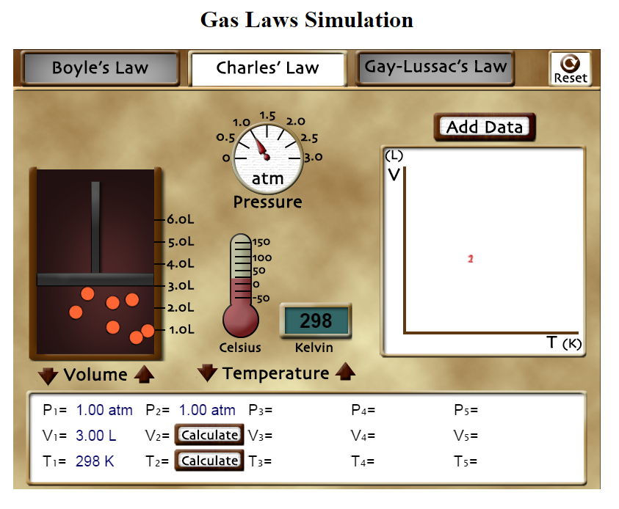
- Which one of the three variables: Pressure, Volume or Temperature cannot be changed in Charles’ Law? This variable is considered a constant.

- a. Using the Temperature controls, increase the temperature of the gas. What changes do you observe in the behavior of the particles of the gas while the temperature is increased?
b. Continue to increase the temperature value until T₂ = 443K. Using the equation for Charles’ law, calculate the volume of the gas at this increased temperature. Check your final answer for part b by clicking the calculate button next to V₂:

V₁ = V₂
T₁ T₂

c. Based on the final value calculated in part b) is Charles’ law considered a direct or an indirect relationship between the variables? Explain your choice with reasoning.

- Press the reset button at the top right of the screen.
Using the volume control arrows, reduce the volume of the gas to 1.86L.
  - In the space below record your observations regarding the behavior of the particles in the gas sample as the volume is reduced.
  - In the space below calculate the new temperature value for the gas.
  - Check your final answer for part b by clicking the calculate button next to T₂.

a. Observations when Volume is reduced: | b. Calculation
V₁ = V₂
T₁ T₂

  - Convert the final value for T₂ into Celsius units.

- Press the reset button at the top right of the screen.
- Using the pressure control arrows, increase the temperature value to a measurement of your choosing. Then press Add Data. This will fix a data point on the graph for T₂.
- Increase the temperature three additional times; select Add Data for each data point: T_{3,} T_{4,} and T_{5.}

  - Plot these points on the graph below, estimating the five data points created:

Volume (L)

Temperature (K)

  - Based on the data points collected on the graph, make a statement about the trend that can be observed between the volume and temperature of a gas.

- Considering what you now know about Charles’ law, make a prediction based on the following situation: What would happen to the volume of a gas inside a sealed bottle, if the bottle was heated to double its original temperature? Explain your thoughts.

Gay-Lussac’s Law
Change the simulation to “Gay-Lussac’s Law” by clicking the tab at the top of the screen it will be shown in white. You should see the picture below on your screen.

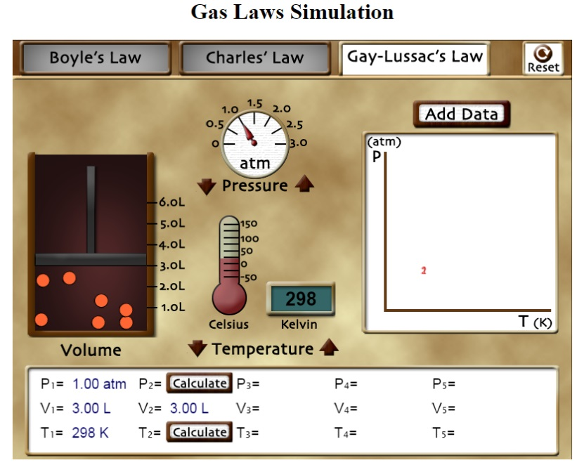
P₁ = P₂
T₁ T₂

- a. The equation for Gay-Lussac’s law is does it look most similar to the equation for Boyle’s Law or the equation for Charles’ law?

b. What variable is held constant in Gay Lussac’s law?

c. Based on your answer to part a) what prediction can you make about the relationship between the variables of Pressure and Temperature of a gas?

- a. Using the pressure control arrows, increase the pressure value to 1.50atm, and
fill in the corresponding T₂ value in the data table below.
- Press the Add Data button. Using the pressure control arrows, increase the pressure to 2.00atm and fill in the corresponding T₃ value in the data table below.
- Repeat step b for pressure values of 2.50atm and 2.90atm.

P₁ = 1.00atm | P₂ = 1.50atm | P₃ = 2.00atm | P₄ = 2.50atm | P₅ = 2.90atm
T₁ = | T₂ = | T₃ = | T₄ = | T₅ =

- Based on the data collected in the table above, what trend can be observed for temperature of a gas when the pressure of the gas is increased? Is this considered a direct or an indirect relationship between the variables?

- Press the reset button at the top right of the screen.
Using the temperature control arrows, reduce the temperature of the gas to 158K.
  - In the space below record your observations regarding the behavior of the particles in the gas sample as the temperature is reduced. Make certain to discuss collisions in your comments.
  - In the space below calculate the new pressure value for the gas.
  - Check your final answer for part b by clicking the calculate button next to P₂.

a. Observations when Volume is reduced: | b. Calculation
P₁ = P₂
T₁ T₂

- Considering what you now know about Gay-Lussac’s law, make a prediction based on the following situation: What would happen to the pressure of a gas inside a sealed bottle, if the bottle was cooled to half of its original temperature? Explain your thoughts.

Checking Comprehension
Please create a list of the variable given in each problem and show all your work required to complete the calculation.

- Calculate the temperature of a gas when it is expanded to 5.25L. The gas originally occupies 3.45L of space at 282K.

- The temperature of a gas is increased from 125⁰C to 182⁰C inside of a rigid container. The original pressure of the gas was 1.22atm, what will the pressure of the gas be after the temperature change?

- The volume of gas in a container was originally 3.24L, while at standard pressure, 1.00atm. What will the volume be if the pressure is increased to 1.20atm?

