Concentration & Molarity Activity

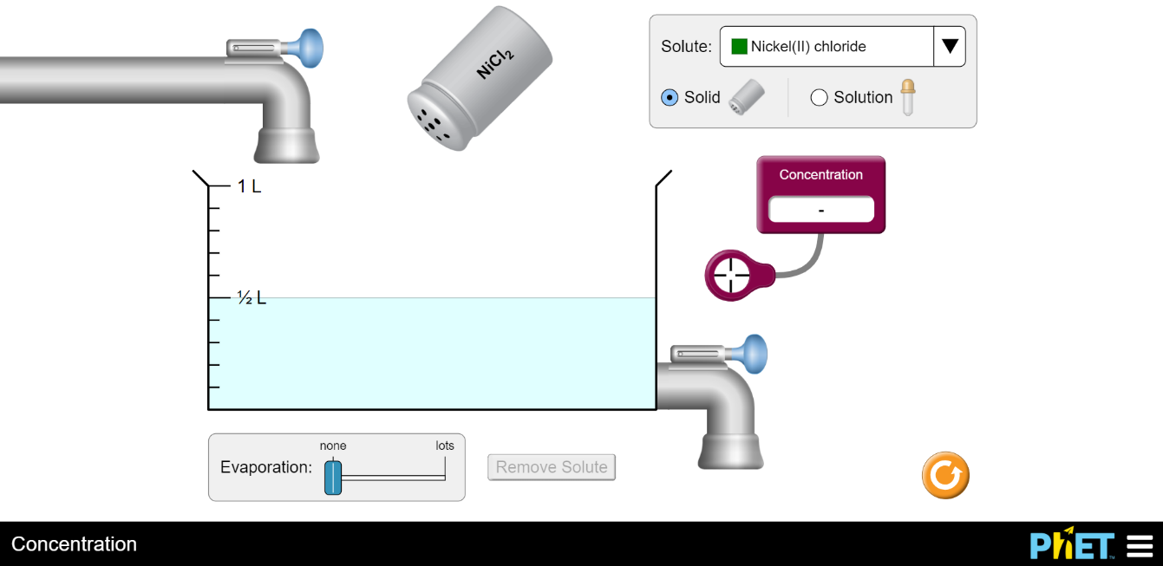
Use to measure the concentration of the water

https://phet.colorado.edu/sims/html/concentration/latest/concentration_en.html

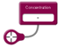

Concentration measurement device

Variables that effect concentration
- Open the above link
- Add a few shakes of solid Nickel (II) Chloride to the water tank, by grabbing the shaker with your mouse and moving it up and down.
- Measure the concentration by dragging the concentration measuring device (see picture above) into the solution. Record the concentration in the table below as initial concentration
- Add some more solid Nickel (II) Chloride to the water tank.
- Measure and record the new concentration of the solution.
- Then add water by pulling the blue tab on the tube above the water tank.
- After the water is added, measure and record the new concentration.
- Drain some water by pulling the blue tab on the tube to the right of the tank. Do not drain all the water.
- After the water is drained, measure and record the new concentration.
- Evaporate the solution by moving the evaporation tab to the right. Make sure there is still liquid in the tank, do not evaporate all the solution.
- After the water is evaporated measure and record the new concentration.

Changing variable | Concentration
Initial Concentration
After adding more Nickel (II) Chloride
After adding water
After draining water
After evaporating the water

Analysis
- How does the concentration of the solution change when more Nickel (II) Chloride is added?

- How does the concentration of the solution change when water is added?

- How does the concentration of the solution change when water is drained?

- How does the concentration of the solution change when water is evaporated?

- You go to your fridge and pour yourself some lemonade. When you taste the lemonade, it tastes more like water than lemonade. What are 2 ways that you could make the lemonade taste more like lemonade?

- You go to your fridge and pour yourself some lemonade again. When you taste the lemonade, this time it tastes way too strong and it is too concentrated to drink. What are 2 ways that you could make the lemonade less concentrated to drink?

- What is the relationship (direct or inverse) between molarity and the solute amount? A solute is a substance that is dissolved in another substance. (Direct -when one variable goes up the, the other variable goes up. Inverse- when one variable goes up the, the other variable goes down.)

- What is the relationship (direct or inverse) between molarity and the solvent volume? A solvent is a substance that dissolves a solute.

- We know that the units for concentration are mols/L. Use your initial concentration and calculate how many moles of Nickel (II) Chloride you added to the water. (Hint: your initial volume should be 0.5 L and Molarity is your conversion factor)

- Now that you know how many moles of Nickel (II) Chloride you added to your water, calculate how many grams of Nickel (II) Chloride you added.

