Meadowview Calendar of Events | Event Dates 2018-19 | Time
Back to School Chalk Fest | Wednesday, August 29th | 6-8pm
Back to School Day | Tuesday, September 4th | all day
Coupon Book Sale kick-off at school | Tuesday, September 11th | books handed out at school
Dairy Queen Night (10% goes to PTO) | Tuesday, September 11th | evening
Vision Screening | Wednesday, Sept. 12th | during school
Hearing Screening | Friday, September 21st | during school
Coupon Book Sale ends | Tuesday, September 25th | at school
Culvers Night (Golf Road location-% goes to PTO) | Tuesday, September 25th | 4-7pm
Memorial High School Homecoming Parade | Friday, September 28th | evening
Meadowview Mile Shirt Pick up at School | Monday, October 1st | 5-7pm
Meadowview Mile at Fairfax Park | Tuesday, October 2nd | 5:30-8pm
Dairy Queen Night on Golf (10% goes to PTO) | Tuesday, October 9th | evening
Picture Day | Thursday, October 11th | 8:15am-11:45am
PTO Meeting-Childcare Provided | Thursday, October 18th | 5:30-6:30pm
Popcorn Day at School-Donate $.25 | Friday, October 19th | during school
Culvers Night (Golf Road Location-% goes to PTO) | Tuesday, October 23rd | 4-7pm
Parent Teacher Conferences | Thursday, October 25th | throughout the day
Halloween Parade at School | Wednesday, October 31st | 2:35pm
Bingo Family Night | Thursday, November 8th | evening
Dairy Queen Night on Golf (10% goes to PTO) | Tuesday, November 13th | evening
Dairy Queen Night on Golf (10% goes to PTO) | Tuesday, December 11th | evening
Dairy Queen Night on Golf (10% goes to PTO) | Tuesday, January 8th | evening
Popcorn Day at School-donate $.25 | Friday, January 18th | during school
Impressions Art Fair | Thursday, January 31st | evening
PTO Meeting-childcare provided | Tuesday, February 5th | 5:30-6:30pm
Dairy Queen Night on Golf (10% goes to PTO) | Tuesday, February 12th | evening
Parent Teacher Conferences | Thursday, February 21st | throughout the day
Learning Fun Night | Thursday, March 7th | evening
Dairy Queen Night on Golf (10% goes to PTO) | Tuesday, March 12th | evening
Popcorn Day at School-donate $.25 | Friday, March 15th | during school
Culvers Night (Golf Road location-% goes to PTO) | Thursday, March 21st | 4-7pm
Dairy Queen Night on Golf (10% goes to PTO) | Tuesday, April 9th | evening
Spring Dance | Thursday, April 11th | evening
PTO Meeting-childcare provided | Monday, April 15th | 5:30-6:30pm
Culvers Night (Golf Road location-% goes to PTO) | Tuesday, April 23rd | 4-7pm
Teacher Appreciation Week | May 6th-10th | all week
Dairy Queen Night on Golf (10% goes to PTO) | Tuesday, May 14th | evening
5th Grade Party | Friday, May 31st | mid-morning
Carnival | Thursday, June 6th | 12-3pm
Meadowview Night at the Minnesota Twins Game | TBD-tickets will be sold at school | TBD
Reminder: Send in your Box Tops
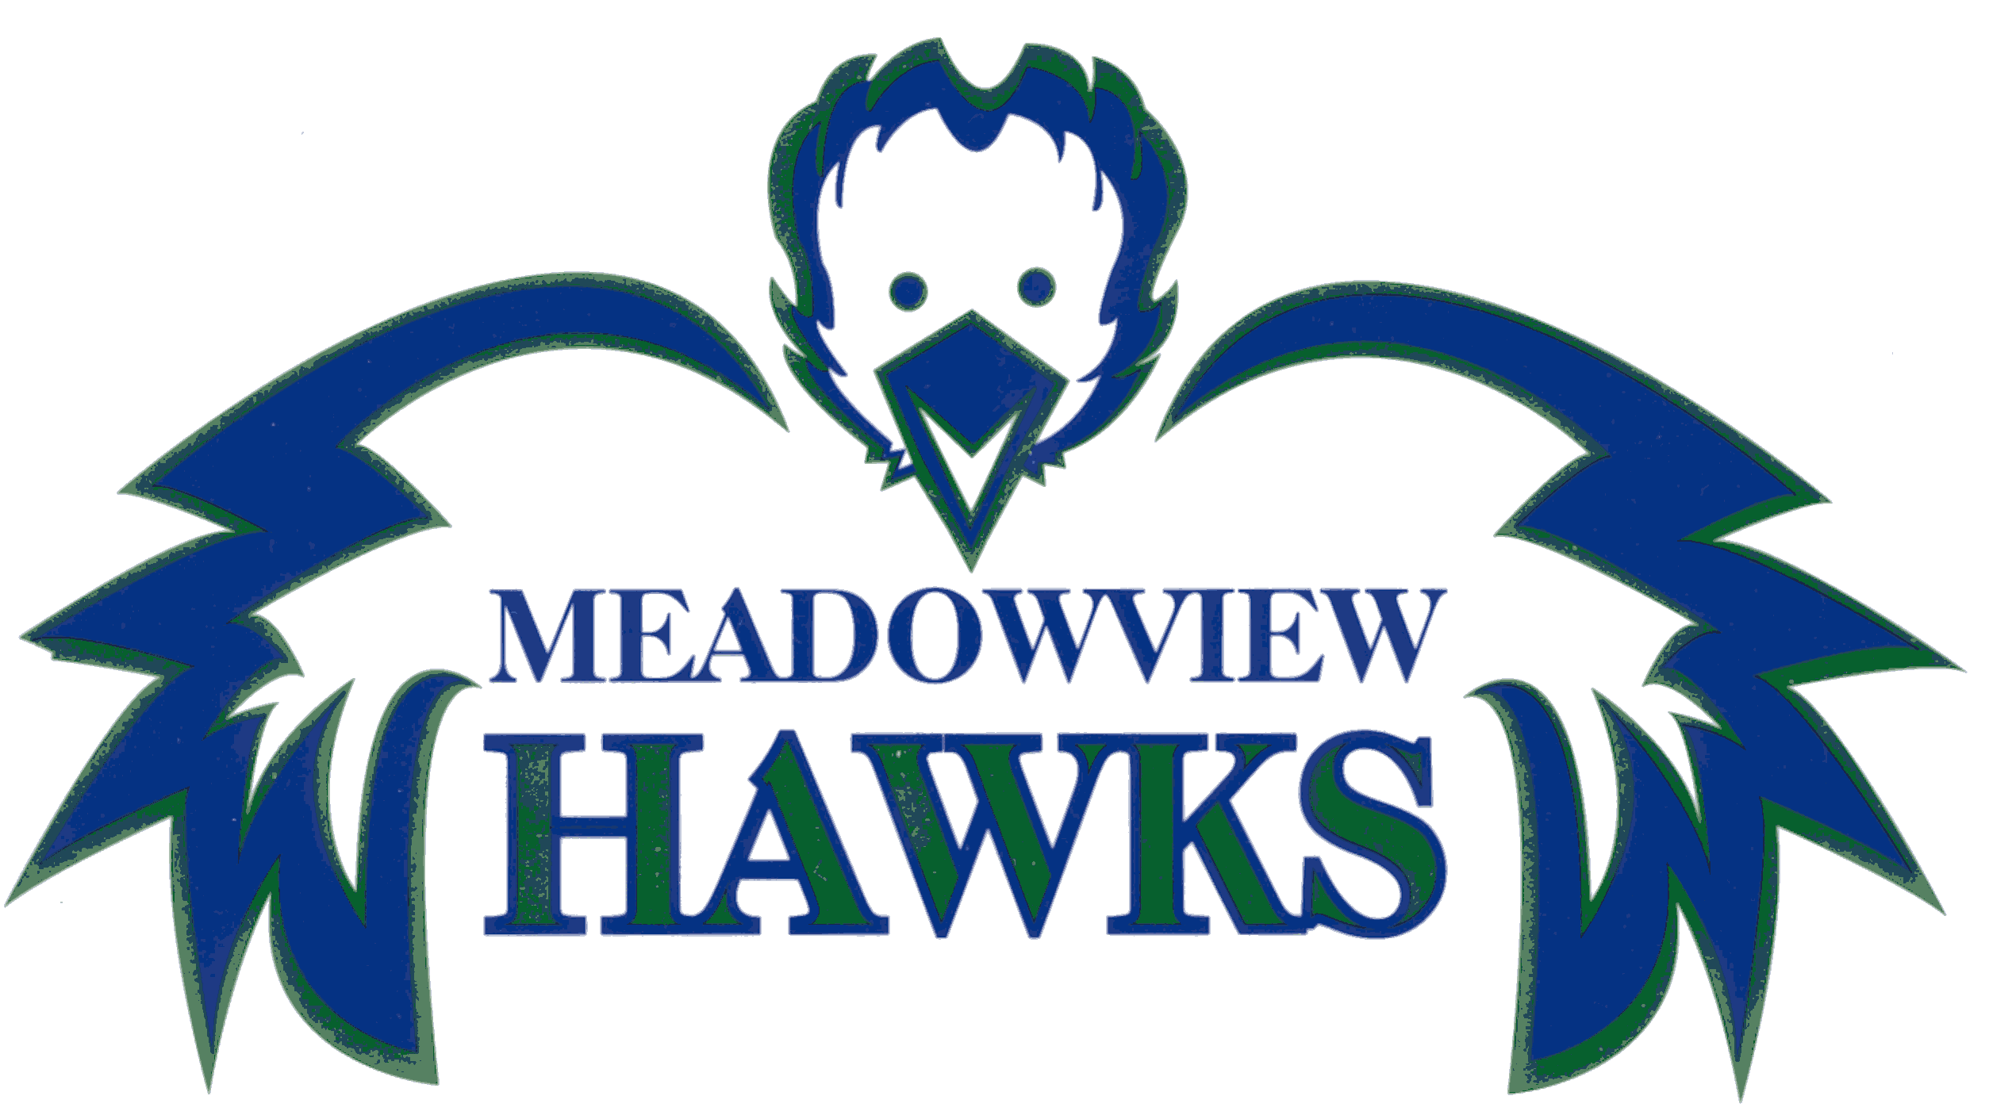

Meadowview Spirit Days | Dates
Meadowview Attire or Green and Blue Day | September 7th
Wear Purple for Memorial Homecoming | September 28th
Meadowview Attire or Green and Blue Day | October 5th
Crazy Hair Day | October 19th
Meadowview Attire or Green and Blue Day | November 2nd
Hat Day | November 30th
Meadowview Attire or Green and Blue Day | December 7th
Wear Something Tie Dye | December 17th
Pajama Day | December 18th
Mix Match Sock Day | December 19th
Kind Day-Give a Staff Member a Nice Note | December 20th
Wear Green and Red | December 21st
Meadowview Attire or Green and Blue Day | January 11th
Meadowview Attire or Green and Blue Day | February 1st
Valentine's Day-Wear Red and White | February 14th
Meadowview Attire or Green and Blue Day | March 1st
Meadowview Attire or Green and Blue Day | April 5th
Meadowview Attire or Green and Blue Day | May 3rd

