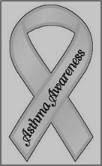
May is Asthma Awareness Month
Asthma is a lung condition that causes difficulty breathing, and it's common among kids and teens. Symptoms include coughing, wheezing, and shortness of breath. Anyone can have asthma, even infants, and the tendency to develop the condition is often inherited.
Environmental Factors:
Indoor and outdoor environmental factors can trigger asthma attacks.
Common triggers include:
- allergens, including microscopic dust mites present in house dust, carpets, and pillows; animal dander and saliva; pollens and grasses; molds; foods; medications; and cockroaches
- viral infections, including the common cold and the flu
- irritants, including smoke, air fresheners, aerosols, paint fumes, hair spray, and perfumes
- exercise
- breathing in cold air
- weather changes
Asthma Can be Controlled:
With a plan that includes medical treatment and control of environmental triggers, people with asthma can lead healthy, active lives.
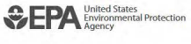

A medication form is required if your child has an inhaler at school, even if they plan to carry it and use it independently. Please follow the link below to access the district’s Medication Management Form. A new form must be completed each school year. In order for your child to be able to carry their own inhaler, the physician/licensed prescriber must indicate that on the form.
http://www.ecasd.us/getattachment/District/Departments/School-Nurses/Medication-Management-Form-parts-A-and-B-revised-5-13.pdf

