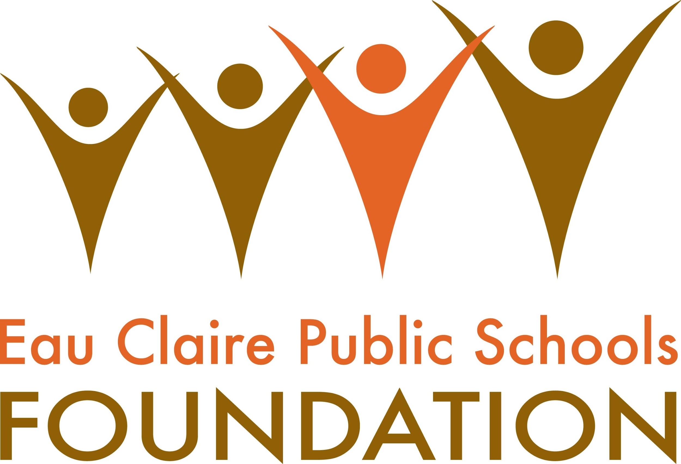 Ross Proctor Memorial Scholarship Guidelines

The Ross Proctor Music Scholarship Fund was established by the Kathyrn Proctor Duax family and friends in memory of Carson Ross Proctor, North High School Class of 1994. Ross’s family established this scholarship in his memory to support students at North High School who share Ross’s passion and talent for music.
Accepted applicants must be: have the intent of majoring or minoring in some type of music program (vocal, performance, composing, music therapy, music education, etc.). They must have a B average or better and be recommended by a NHS music teacher. Selection will be based on the criteria stated in the description. If there is a tie in the rubric the reviewers will rank order the applicants.

Criteria
All North High School seniors who have participated in NHS music programs will be considered for the Ross Proctor Memorial Scholarship. Selection will be based on:
- Number of years of participation in NHS music programs
- Intent to attend a post-secondary education program as a music major or minor
- GPA – B average or higher
- Recommendation letter from a North High School music teacher

Application
To be considered for the scholarships applicants must submit:
- A typed cover page that includes name, address, phone number, name of post-secondary school, number of years active in the NHS Music program
- A typed one-page essay, describing:
  - Your NHS music activities
  - Ways that you have benefited participating in NHS music program
  - Why music has been important to you
  - Other activities they are active in
  - Your plan for post-secondary education
  - Applications will be submitted to North High School music teachers for recommendation

- Submit the application and 4 copies (5 copies total each with a cover page) to Student Services Office by Monday, March 18, 2024 by 3:30 PM.

Selection and Distribution
Selection will be made by the NHS Scholarship committee. One award of $500 (or more) will be presented annually, and announced at the Pride Ceremony.
Scholarship Funds will be issued in the fall to the student and their post-secondary institution distributed by the Eau Claire Public Schools Foundation (ECPSF).
Recipients will direct requests for scholarship payment to:
ECPSF, Executive Director, 500 Main Street, Eau Claire, Wisconsin, 54701, 715-852-3015. Please supply a transcript or other proof of registration. Checks will only be made payable to secondary educational institutions by law.
Scholarship recipients may send their thank you and an acknowledgement letter to the Proctor Duax Family c/o the Eau Claire Public Schools Foundation at the above address

