Eau Claire North Cross Country – Program Philosophy & Expectations
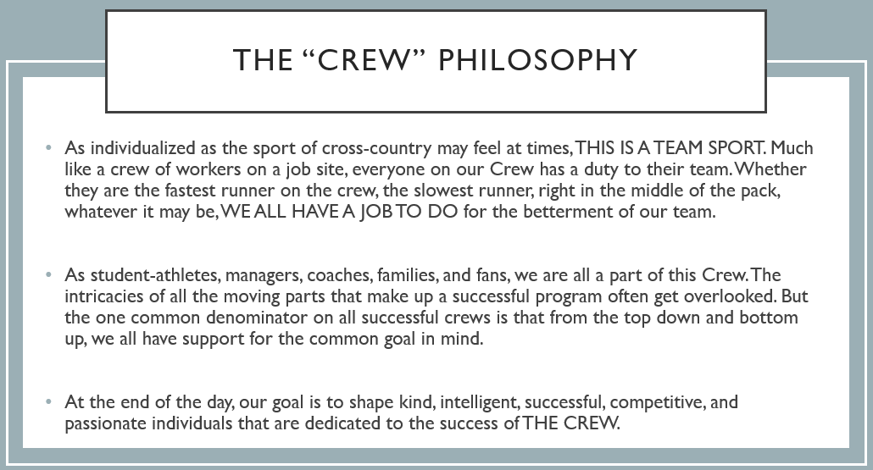

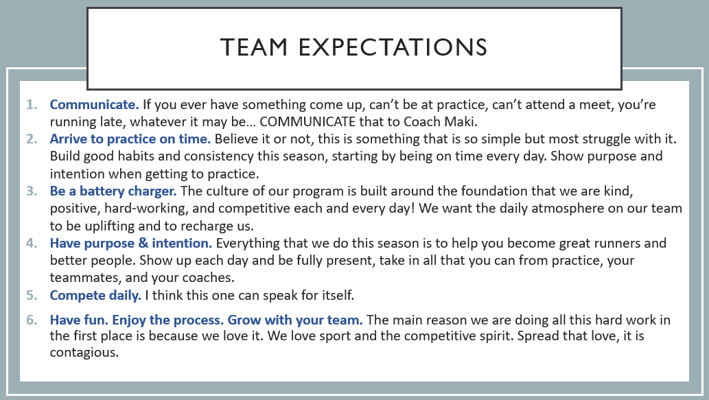
By signing below, I have read the above expectations and hereby signify that I will be true to those expectations to the best of my ability for the duration of the 2022 Fall XC season.

X__________________________________________
(Student athlete signature)

