Directions for Accessing Student Library Accounts
ECASD students have an individual login account which gives them access to Destiny (District Print catalog) and Sora (District Digital catalog). If you wish to get a copy of your student’s login information or if you have any further questions, please contact your school Media and Technology Specialist (librarian).
Destiny Library Catalog (Print Catalog)
- Go to the ECASD Browser Start Page, https://www.ecasd.us/Start-Pages. 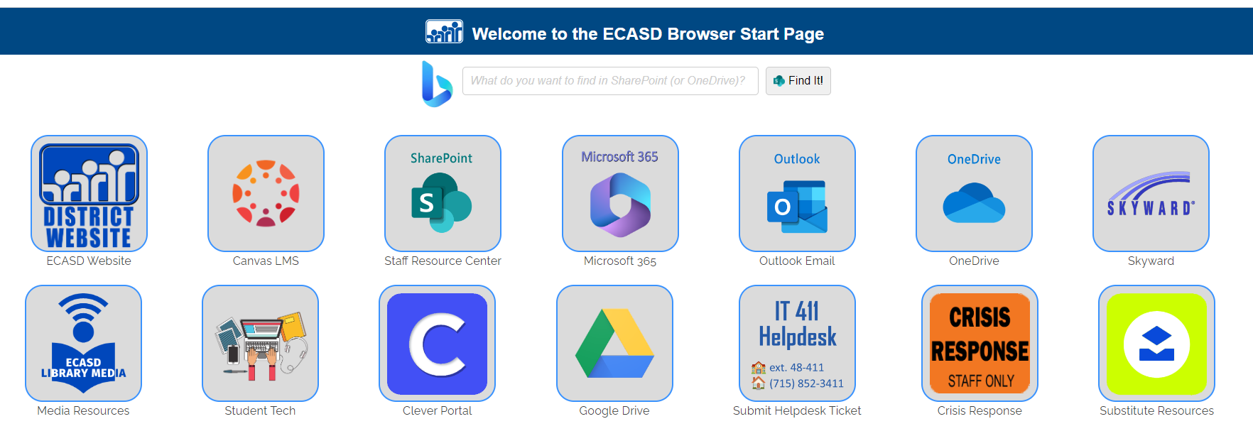
- Select the Clever Portal .
- Select “Use ECASD Login!”
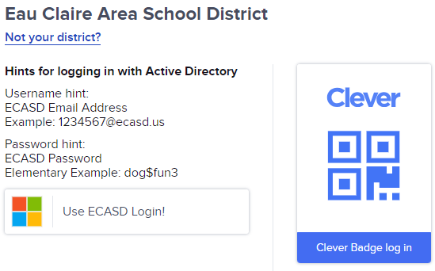
- Enter your student's school email address and password.
- Select the Destiny icon .
- Select Login in the upper right corner.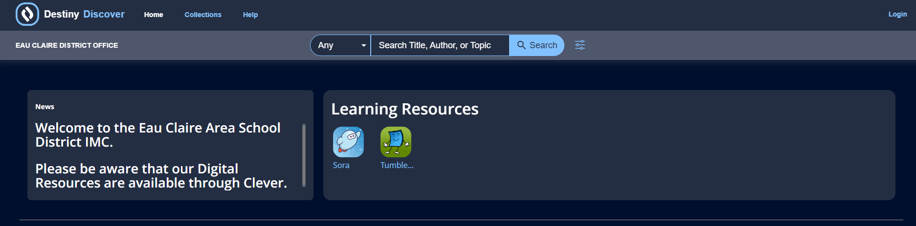
- Select Eau Claire Area School District. Your device may authenticate again.
- Select the My Stuff tab in the upper left corner, and you will see the library items your student has out.

Sora (Digital Catalog)
- Go to the ECASD Browser Start Page, https://www.ecasd.us/Start-Pages.
- Select the Clever Portal .
- Select “Use ECASD Login!”
- Enter your student's school email address and password.
- Select the Sora icon .
- Select Eau Claire Area School District. Your device may authenticate again.
- Click on shelf at the bottom of the screen to see what your student has checked out.

